**Mathematics In The Modern World**

Module #1

**Topic: THE NATURE OF MATHEMATICS**

**MATHEMATICS is:**

* the study of pattern and structure.
* a useful way to think about nature and our world.
* a tool to quantify, organize and control our world, predict phenomena and make life easier for us.

**MATHEMATICS is**

* in many patterns and occurrences that exists in nature, in our world, and in our life. Mathematics gives sense to these patterns and occurrences.

**ROLES THAT MATHEMATICS PLAY IN OUR WORLD**

1. **Mathematics helps organize patterns and regularities in our world like:**
2. Patterns can be observed even in stars which move in circles across the sky each day.
3. The weather season cycle each year. All snowflakes contains sixfold symmetry which no two are exactly the same.



1. Patterns can be seen in fish patterns like spotted trunkfish, spotted puffer, blue spotted stingray, spotted moral eel, coral grouper, redlion fish, yellow boxfish and angel fish. These animals and fish stripes and spots attest to mathematical regularities in biological growth and form.

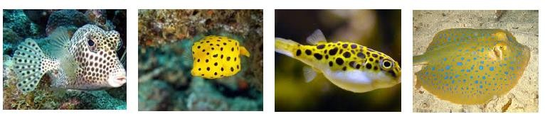

1. Zebras, tigers, cats and snakes are covered in patterns of stripes; leopards and hyenas are covered in pattern of spots and giraffes are covered in pattern of blotches.

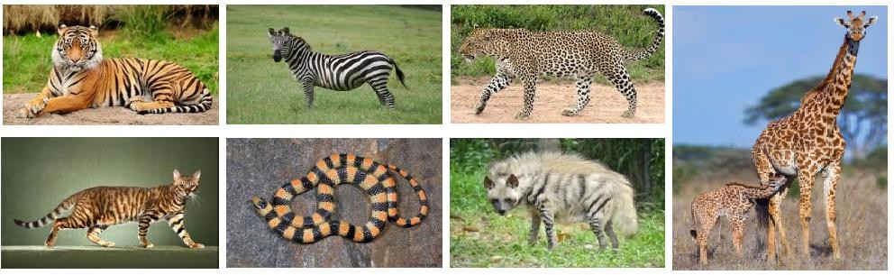

1. Natural patterns like the intricate waves across the oceans; sand dunes on deserts; formation of typhoon; water drop with ripple and others. These serves as clues to the rules that govern the flow of water, sand and air.

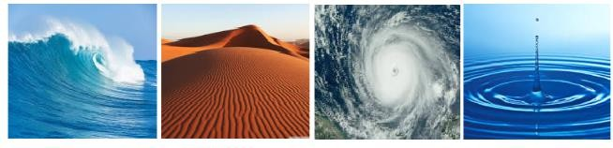

1. Other patterns in nature can also be seen in the ball of mackerel, the v-formation of geese in the sky and the tornado formation

of starlings.

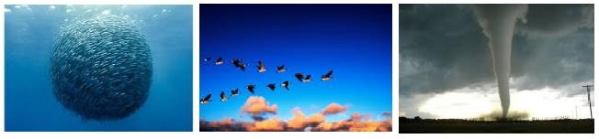

1. **Mathematics helps predict the behavior of nature and phenomena in the world.**

Mathematics is all around us. As we discover more about our environment, we can mathematically describe nature. The beauty of a flower, the majestic tree, even the rock formation exhibits nature’s sense of symmetry.

**TYPES OF PATTERNS**

1. **SYMMETRY** – a sense of harmonious and beautiful proportion of balance or an object is invariant to any various transformations (reflection, rotation or scaling.)

1. ***Bilateral Symmetry***: a symmetry in which the left and right sides of the organism can be divided into approximately mirror image of each other along the midline. Symmetry exists in living things such as in insects, animals, plants, flowers and others. Animals have mainly bilateral or vertical symmetry, even leaves of plants and some flowers such as orchids.

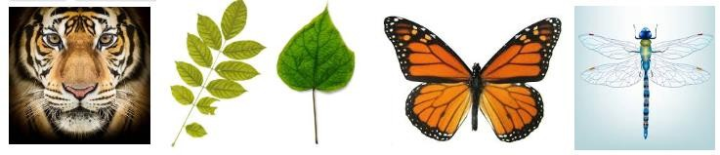

1. ***Radial Symmetry (or rotational symmetry)*:** a symmetry around a fixed point known as the center and it can be classified as either ***cyclic or dihedral***. Plants often have radial or rotational symmetry, as to flowers and some group of animals. A five-fold symmetry is found in the echinoderms, the group in which includes starfish (dihedral-D5 symmetry), sea urchins and sea lilies. Radial symmetry suits organism like sea anemones whose adults do not move and jellyfish (dihedral-D4 symmetry). Radial symmetry is also evident in different kinds of flowers.
2. **FRACTALS –** a curve or geometric figure, each part of which has the same statistical character as the whole. A ***fractal*** is a never- ending pattern found in nature. The exact same shape is replicated in a process called “self-similarity.” The pattern repeats itself over and over again at different scales. For example, a tree grows by repetitive branching. This same kind of branching can be seen in lightning bolts and the veins in your body. Examine a single fern or an aerial view of an entire river system and you’ll see fractal patterns.

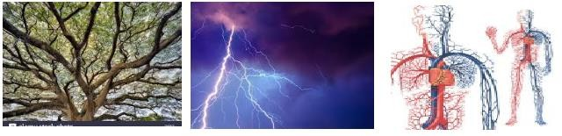

1. **SPIRALS -** A logarithmic spiral or growth spiral is a self-similar spiral curve which often appears in nature. It was first describe by Rene Descartes and was later investigated by Jacob Bernoulli. A ***spiral*** is a curved pattern that focuses on a center point and a series of circular shapes that revolve around it. Examples of spirals are pine cones, pineapples, hurricanes. The reason for why plants use a spiral form is because they are constantly trying to grow but stay secure.

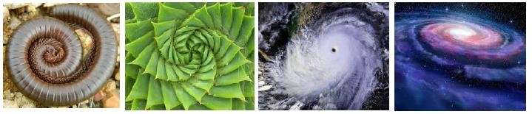

**FIBONACCI NUMBERS IN NATURE**

Flower petals exhibit the Fibonacci number, white calla lily contains 1 petal, euphorbia contains 2 petals, trillium contains 3 petals, columbine contains 5 petals, bloodroot contains 8 petals, black-eyed susan contains 13 petals, shasta daisies 21 petals, field daisies contains

34 petals and other types of daisies contain 55 and 89

petals.

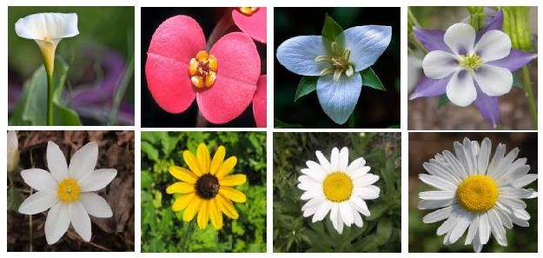

**FIBONACCI SEQUENCE IN NATURE**

The sunflower seed conveys the Fibonacci sequence. The pattern of two spirals goes in opposing directions (clockwise and counter-clockwise). The number of clockwise spirals and counter clockwise spirals are consecutive Fibonacci numbers and usually contains 34 and 55 seeds.

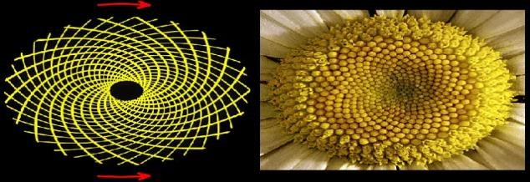

The Fibonacci sequence can also be seen in the way tree branches form or split. A main trunk will grow until it produces a branch, which creates two growth points. Then, one of the new stems branches into two, while the other one lies dormant. This pattern of branching is repeated for each of the new stems. A good example is the sneezewort. Root systems and even algae exhibit this pattern.

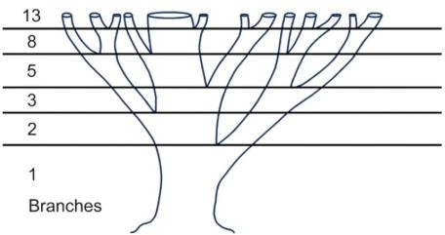

**FIBONACCI SEQUENCE**

The Fibonacci sequence is a series of numbers where a number is found by adding up the two numbers before it. Starting with 0 and 1, the sequence goes 0, 1, 1, 2, 3, 5, 8, 13, 21, 34, and so forth. Written as rule, the expression is

𝑿𝒏 = 𝑿𝒏−𝟏 + 𝑿𝒏−𝟐

From the discussion above, we are able to recognize patterns. In mathematics, we can generate patterns by performing one or several mathematical operations repeatedly. WE call these ordered lists of numbers a sequence.

The sequence 1, 1, 2, 3, 5, 8, 13, 21, 34, 55, 89, 144, 233, 377, …

is called the **Fibonacci sequence** and its terms are the **Fibonacci numbers**.

**D. Mathematics helps control nature and occurrences in the world for our own ends.**

**E. Mathematics has numerous applications in the world making it indispensable.**

**GOLDEN RATIO**

**Nature of Mathematics** – (Ppt. Presentation) see attached fil

**CHAPTER 1**

**MATHEMATICS IN OUR WORLD**

**Intended Learning Outcomes (ILO):**

1. ***Identify patterns in nature and regularities in the world.***
2. ***Articulate the importance of mathematics in one’s life.***
3. ***Argue about the nature of mathematics, what is it, how it is expressed, represented and used.***
4. ***Express appreciation for mathematics as a human endeavor.***

***WHAT IS MATHEMATICS?***

* Mathematics is the study of pattern and structure. Mathematics is fundamental to the physical and biological sciences, engineering and information technology, to economics and increasingly to the social sciences.
* Mathematics is a useful way to think about nature and our world.
* Mathematics is a tool to quantify, organize and control our world, predict phenomena and make life easier for us.

***WHERE IS MATHEMATICS?***

* Many patterns and occurrences exists in nature, in our world, in our life. Mathematics helps make sense of these patterns and occurrences.

***WHAT ROLE DOES MATHEMATICS PLAY IN OUR WORLD?***

* Mathematics helps organize patterns and regularities in our world.
* Mathematics helps predict the behavior of nature and phenomena in the world.
* Mathematics helps control nature and occurrences in the world for our own ends.
* Mathematics has numerous applications in the world making it indispensable.

***PATTERNS AND NUMBERS IN NATURE AND THE WORLD***

Patterns in nature are visible regularities of form found in the natural world and can also be seen in the universe.

Nature patterns which are not just to be admired, they are vital clues to the rules that govern natural processes.

***Check out examples of some of these patterns and you may be able to spot a few the next time you go for a walk.***

1. Patterns can be observed even in stars which move in circles across the sky each day.
2. The weather season cycle each year. All snowflakes contains sixfold symmetry which no two are exactly the same.

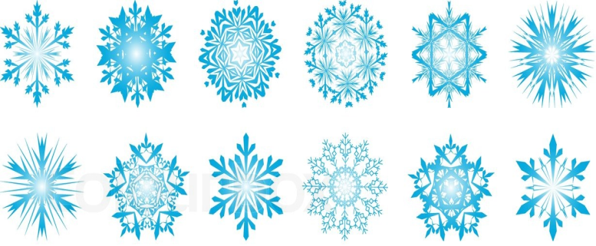

1. Patterns can be seen in fish patterns like spotted trunkfish, spotted puffer, blue spotted stingray, spotted moral eel, coral grouper, redlion fish, yellow boxfish and angel fish. These animals and fish stripes and spots attest to mathematical regularities in biological growth and form.

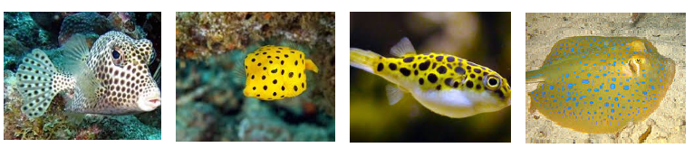

1. Zebras, tigers, cats and snakes are covered in patterns of stripes; leopards and hyenas are covered in pattern of spots and giraffes are covered in pattern of blotches.

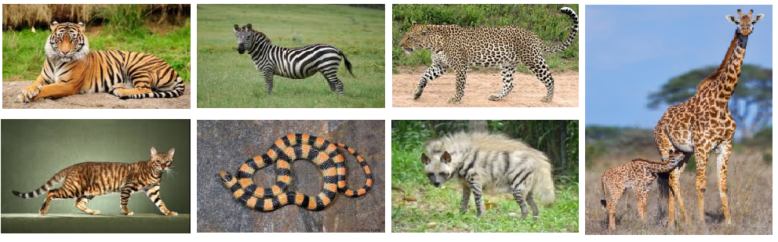

1. Natural patterns like the intricate waves across the oceans; sand dunes on deserts; formation of typhoon; water drop with ripple and others. These serves as clues to the rules that govern the flow of water, sand and air.

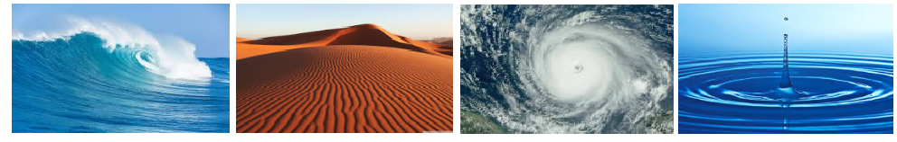

1. Other patterns in nature can also be seen in the ball of mackerel, the v-formation of geese in the sky and the tornado formation of starlings.

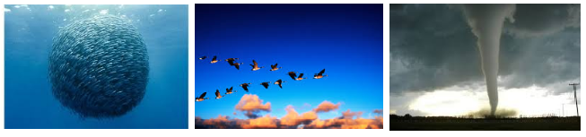

**PATTERNS AND REGULARITIES**

Mathematics is all around us. As we discover more about our environment, we can mathematically describe nature. The beauty of a flower, the majestic tree, even the rock formation exhibits nature’s sense of symmetry.

Have you ever thought about how nature likes to arrange itself in patterns in order to act efficiently? Nothing in nature happens without a reason, all of these patterns have an important reason to exist and they also happen to be beautiful to watch.

**TYPES OF PATTERNS**

1. **SYMMETRY** – a sense of harmonious and beautiful proportion of balance or an object is invariant to any various transformations (reflection, rotation or scaling.)

***a.) Bilateral Symmetry***: a symmetry in which the left and right sides of the organism can be divided into approximately mirror image of each other along the midline. Symmetry exists in living things such as in insects, animals, plants, flowers and others. Animals have mainly bilateral or vertical symmetry, even leaves of plants and some flowers such as orchids.



1. ***Radial Symmetry ( or rotational symmetry )*:**a symmetry around a fixed pointknown as the center and it can be classified as either ***cyclic or dihedral***. Plants often have radial or rotational symmetry, as to flowers and some group of animals. A five-fold symmetry is found in the echinoderms, the group in which includes starfish (dihedral-D5 symmetry), sea urchins and sea lilies. Radial symmetry suits organism like sea anemones whose adults do not move and jellyfish(dihedral-D4 symmetry). Radial symmetry is also evident in different kinds of flowers.

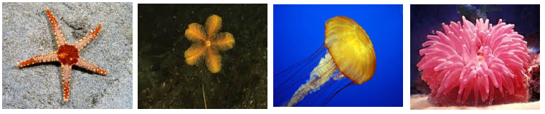

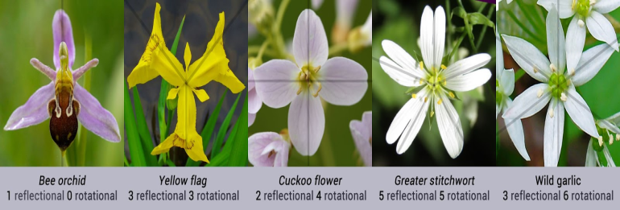

1. **FRACTALS –** a curve or geometric figure, each part of which has the same statistical character as the whole. A ***fractal*** is a never-ending pattern found in nature. The exact same shape is replicated in a process called “self similarity.” The pattern repeats itself over and over again at different scales. For example, a tree grows by repetitive branching. This same kind of branching can be seen in lightning bolts and the veins in your body. Examine a single fern or an aerial view of an entire river system and you’ll see fractal patterns.

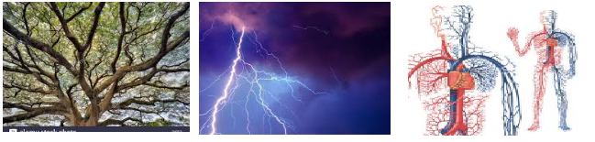

1. **SPIRALS -** A logarithmic spiral or growth spiral is a self-similar spiral curve which often appears in nature. It was first describe by Rene Descartes and was later investigated by Jacob Bernoulli. A ***spiral*** is a curved pattern that focuses on a center point and a series of circular shapes that revolve around it. Examples of spirals are pine cones, pineapples, hurricanes. The reason for why plants use a spiral form is because they are constantly trying to grow but stay secure.

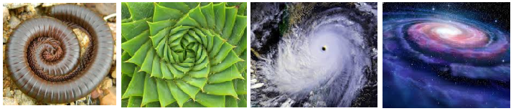

**FIBONACCI SEQUENCE**

The Fibonacci sequence is a series of numbers where a number is found by adding up the two numbers before it. Starting with 0 and 1, the sequence goes 0, 1, 1, 2, 3, 5, 8, 13, 21, 34, and so forth. Written as a rule, the expression is

$$X_{n}=X_{n-1}+X_{n-2}$$

Named after Fibonacci, also known as Leonardo of Pisa or Leonardo Pisano, Fibonacci numbers were first introduced in his Liber Abbaci (Book of Calculation) in 1202. The son of a Pisan merchant, Fibonacci traveled widely and traded extensively. Mathematics was incredibly important to those in the trading industry, and his passion for numbers was cultivated in his youth.

**THE HABBIT RABBIT**

One of the book’s exercises which is written like this “A man put a pair of rabbits in a place surrounded on all sides by a wall. How many pairs of rabbits are produced from that pair in a year, if it supposed that every month each pair produces a new pair, which from the second month onwards becomes productive?” This is best understood in this diagram:

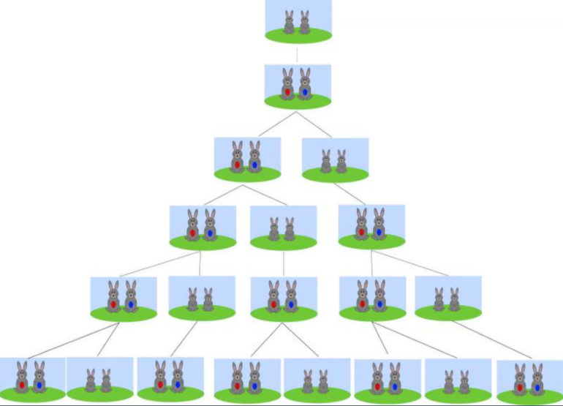

|  |  |  |  |
| --- | --- | --- | --- |
| **GROWTH OF RABBIT COLONY** | | | |
| **MONTHS** | **ADULT PAIRS** | **YOUNG PAIRS** | **TOTAL** |
| 1 | 1 | 1 | 2 |
| 2 | 2 | 1 | 3 |
| 3 | 3 | 2 | 5 |
| 4 | 5 | 3 | 8 |
| 5 | 8 | 5 | 13 |
| 6 | 13 | 8 | 21 |
| 7 | 21 | 13 | 34 |
| 8 | 34 | 21 | 55 |
| 9 | 55 | 34 | 89 |
| 10 | 89 | 55 | 144 |
| 11 | 144 | 89 | 233 |
| 12 | 233 | 144 | 377 |

The sequence encountered in the rabbit problem 1, 1, 2, 3, 5, 8, 13, 21, 34, 55, 89, 144, 233, 377, …. is called the ***Fibonacci sequence*** and its terms the ***Fibonacci numbers***.

**GOLDEN RECTANGLE**

Leonardo of Pisa also known as Fibonacci discovered a sequence of numbers that created an interesting numbers that created an interesting pattern the sequence 1, 1, 2, 3, 5, 8, 13, 21, 34… each number is obtained by adding the last two numbers of the sequence forms what is known as ***golden rectangle*** a perfect rectangle. A golden rectangle can be broken down into squares the size of the next Fibonacci number down and below. If we were to take a golden rectangle, break it down to smaller squares based from Fibonacci sequence and divide each with an arc, the pattern begin to take shapes, we begin with Fibonacci spiral in which we can see in nature.

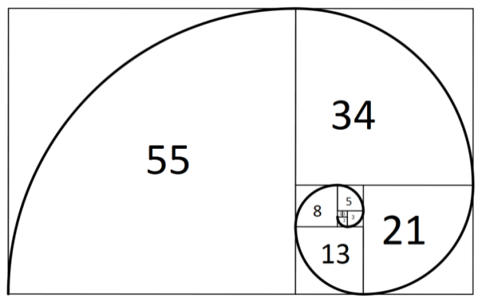

**FIBONACCI NUMBERS IN NATURE**

Flower petals exhibit the Fibonacci number, white calla lily contains 1 petal, euphorbia contains 2 petals, trillium contains 3 petals, columbine contains 5 petals, bloodroot contains 8 petals, black-eyed susan contains 13 petals, shasta daisies 21 petals, field daisies contains 34 petals and other types of daisies contain 55 and 89 petals.

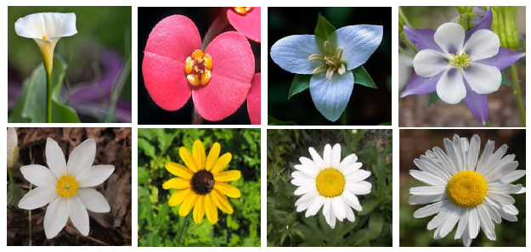

**FIBONACCI SEQUENCE IN NATURE**

The sunflower seed conveys the Fibonacci sequence. The pattern of two spirals goes in opposing directions (clockwise and counter-clockwise ). The number of clockwise spirals and counter clockwise spirals are consecutive Fibonacci numbers and usually contains 34 and 55 seeds.

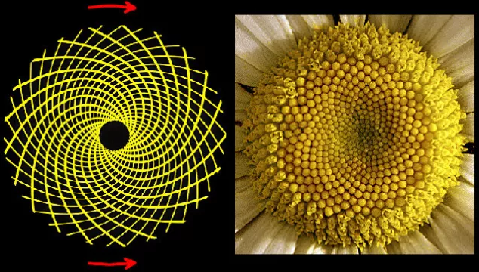

The Fibonacci sequence can also be seen in the way tree branches form or split. A main trunk will grow until it produces a branch, which creates two growth points. Then, one of the new stems branches into two, while the other one lies dormant. This pattern of branching is repeated for each of the new stems. A good example is the sneezewort. Root systems and even algae exhibit this pattern.

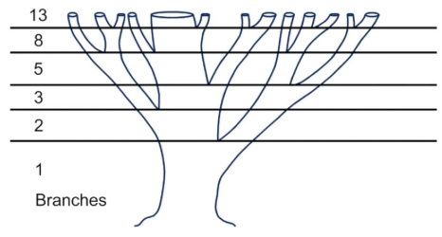

**GOLDEN RATIO**

Fibonacci discovery of Fibonacci sequence happened to approach the ratio asymptotically. He found the interesting and mysterious properties of the Fibonacci sequence that the series has a deep relationship with the golden ratio.

The ***golden ratio*** was first called as the ***Divine Proportion*** in the early 1500s in Leonardo da Vinci’s work which was explored by Luca Pacioli entitled ***“De Divina Proportione”*** in 1509. This contains the drawings of the five platonic solids and it was probably da Vinci who first called it “section aurea” which is Latin for Golden Secion.

In mathematics, two quantities are in the Golden ratio if their ratio is the same of their sum to the larger of the two quantities. The Golden Ratio is the relationship between numbers on the Fibonacci sequence where plotting the relationships on scales results in a spiral shape. In simple terms, golden ratio is expressed as an equation, where ***a*** is larger than ***b,*** (a+b) divided by a is equal to ***a*** divided by ***b***, which is equal to 1.618033987…and represented by $φ$ (phi).

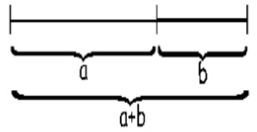

$φ=\frac{a+b}{a}=\frac{a}{b}=1.618033987….$

|  |  |  |
| --- | --- | --- |
| **b** | **a** | **a/b** |
| **2** | **3** | **1.5** |
| **3** | **5** | **1.666666666…** |
| **5** | **8** | **1.6** |
| **8** | **13** | **1.625** |
| **13** | **21** | **1.615384615...** |
| **21** | **34** | **1.61905** |
| **34** | **55** | **1.61765** |
| **.** | **.** | **.** |
| **.** | **.** | **.** |
| **144** | **233** | **1.618055556...** |
| **233** | **377** | **1.618025751...** |

**GOLDEN TRIANGLE**

Golden ratio can be deduced in an isosceles triangle. If we take the isosceles triangle that has the two base angles of 72 degrees and we bisect one of the base angles, we should see that we get another golden triangle that is similar to the golden rectangle. If we apply the same manner as the golden rectangle, we should get a set of whirling triangles. With these whirling triangles, we are able to draw a logarithmic spiral that will converge at the intersection of the two lines. The spiral converges at the intersection of the two lines and this ratio of the lengths of these two lines is in the Golden Ratio.

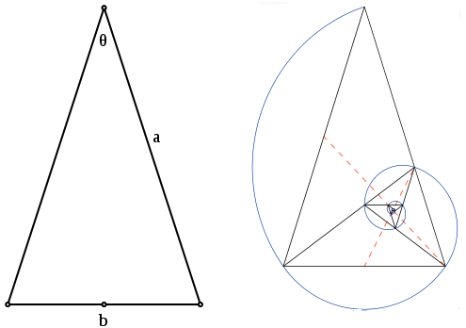

**GOLDEN RATIO IN NATURE**

It is often said that math contains the answers to most of universe’s questions. Math manifests itself everywhere. One such example is the Golden Ratio. This famous Fibonacci sequence has fascinated mathematicians, scientist and artists for many hundreds of years. The Golden Ratio manifests itself in many places across the universe, including right here on Earth, it is part of Earth’s nature and it is part of us.

***1. Flower petals***

number of petals in a flower is often one of the following numbers: 3, 5, 8, 13, 21, 34 or 55. For example, the lily has three petals, buttercups have five of them, the chicory has 21 of them, the daisy has often 34 or 55 petals, etc.

***2. Faces***

Faces, both human and nonhuman, abound with examples of the Golden Ratio. The mouth and nose are each positioned at golden sections of the distance between the eyes and the bottom of the chin. Similar proportions can been seen from the side, and even the eye and ear itself.

***3. Body parts***

The Golden Section is manifested in the structure of the human body. The human body is based on Phi and the number 5.The number 5 appendages to the torso, in the arms, leg and head. 5 appendages on each of these, in the fingers and toes and 5 openings on the face. Animal bodies exhibit similar tendencies.

***4. Seed heads***

Typically, seeds are produced at the center, and then migrate towards the outside to fill all the space. Sunflowers provide a great example of these spiraling patterns.

***5. Fruits, Vegetables and Trees***

Spiraling patterns can be found on pineapples and cauliflower. Fibonacci numbers are seen in the branching of trees or the number of leaves on a floral stem; numbers like 4 are not. 3’s and 5’s, however, are abundant in nature.

***6. Shells***

Snail shells and nautilus shells follow the logarithmic spiral, as does the cochlea of the inner ear. It can also be seen in the horns of certain goats, and the shape of certain spider’s webs.

***7. Spiral Galaxies***

Spiral galaxies are the most common galaxy shape. The Milky Way has several spiral arms, each of them a logarithmic spiral of about 12 degrees.

***8. Hurricanes***

It’s amazing how closely the powerful swirls of hurricane match the Fibonacci sequence.

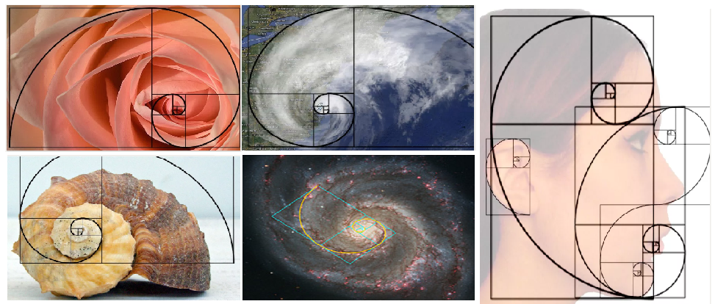

**GOLDEN RATIO IN ARTS**

The golden ratio can be used to achieve beauty, balance and harmony in art, architecture and design. It can be used as a tool in art and design to achieve balance in the composition. Check out some examples of golden ratio in arts.

1. The exterior dimension of the Pathernon in Athens, Greece embodies the golden ratio.

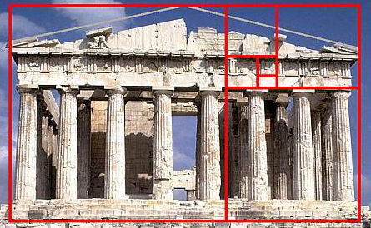

1. In “Timaeus” Plato describes five possible regular solids that relate to the golden ratio which is now known as Platonic Solids. He also considers the golden ratio to be the most bringing of all mathematical relationships.

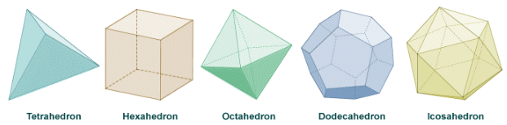

1. Euclid was the first to give definition of the golden ratio as “a dividing line in the extreme and mean ratio” in his book the “Elements”. He proved the link of the numbers to the construction of the pentagram, which is now known as golden ratio. Each intersections to the other edges of a pentagram is a golden ratio. Also the ratio of the length of the shorter segment to the segment bounded by the two intersecting lines is a golden ratio.

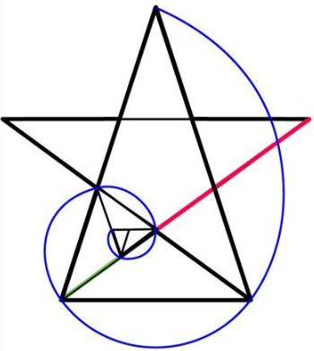

1. ***Leonardo da Vinci*** was into many interests such as invention, painting, sculpting, architecture, science, music, mathematics, engineering, literature, anatomy, geology, botany, writing, history and cartography. He used the golden ratio to define the fundamental portions in his works. He incorporated the golden ratio in his own paintings such as the Vitruvian Man, The Last Supper, Monalisa and St. Jerome in the Wilderness.

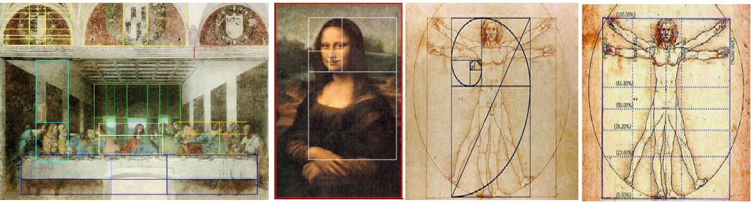

1. 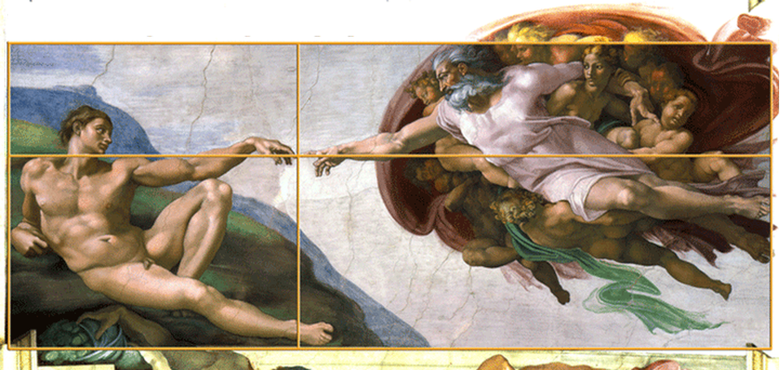***Michaelangelo di Lodovico Simon*** was considered the greatest living artists of his time. He used golden ratio in his painting “The Creation of Adam” which can be seen on the ceiling of the Sistine Chapel. His painting used the golden ratio showing how God’s finger and Adam’s finger meet precisely at the golden ratio point of the weight and the height of the area that contains them.
2. ***Raffaello Sanzio da Urbino*** or more popularly known as Raphael was also a painter and architect from the Rennaisance. In his painting “The School of Athens,”, the division between the figures in the painting and their proportions are distributed using the golden ration. The golden triangle and pentagram can also be found in Raphael’s painting “Crucifixion”.

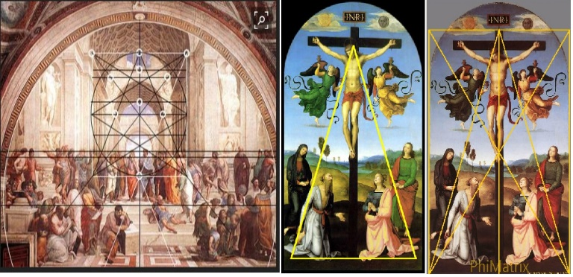

1. The golden ratio can also be found in the works of other renowned painters such as
2. ***Sandro Botticelli*** (Birth of Venus);
3. ***George-Pierre Surat*** (“Bathers at Assinieres”, “Bridge of Courbevoie” and “A Sunday on La Grande Jette”), and
4. ***Salvador Dali*** (“The Sacrament of the Last Supper”).

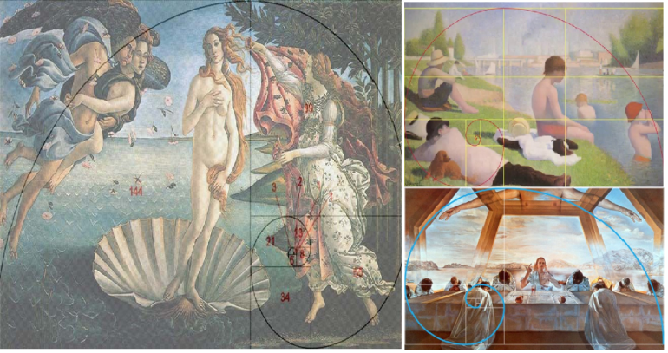

**GOLDEN RATIO IN ARCHITECTURE**

Some of the architectural structures that exhibit the application of the Golden ratio are the following:

1. The ***Great Pyramid of Giza*** built 4700 BC in Ahmes Papyrus of Egypt is with proportion according to a “Golden Ratio”. The length of each side of the base is 756 feet with a height of 481 feet. The ratio of the base to the height is roughly 1.5717, which is close to the Golden ratio.
2. ***Notre Dame*** is a Gothic Cathedral in Paris, which was built in between 1163 and 1250. It appears to have a golden ratio in a number of its key proportions of designs.
3. 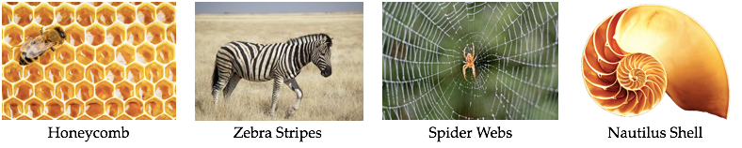The ***Taj Mahal*** in India used the golden ratio in its construction and was completed in 1648. The order and proportion of the arches of the Taj Mahal on the main structure keep reducing proportionately following the golden ratio.
4. The ***Cathedral of Our Lady of Chartres in Paris***, France also exhibits the Golden ratio.
5. In the ***United Nation Building***, the window configuration reveal golden proportion.
6. The ***Eiffel Tower*** in Paris, France, erected in 1889 is an iron lattice. The base is broader while it narrows down the top, perfectly following the golden ratio.
7. The ***CN Tower*** in Toronto, the tallest tower and freestanding structure in the world, contains the golden ratio in its design. The ratio of observation deck at 342 meters to the total height of 553.33 is 0.618 or phi, the reciprocal of phi.

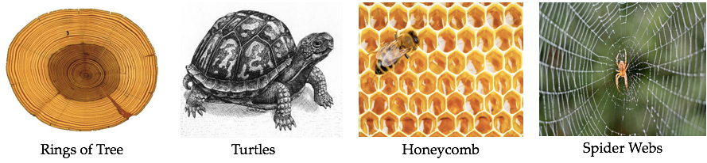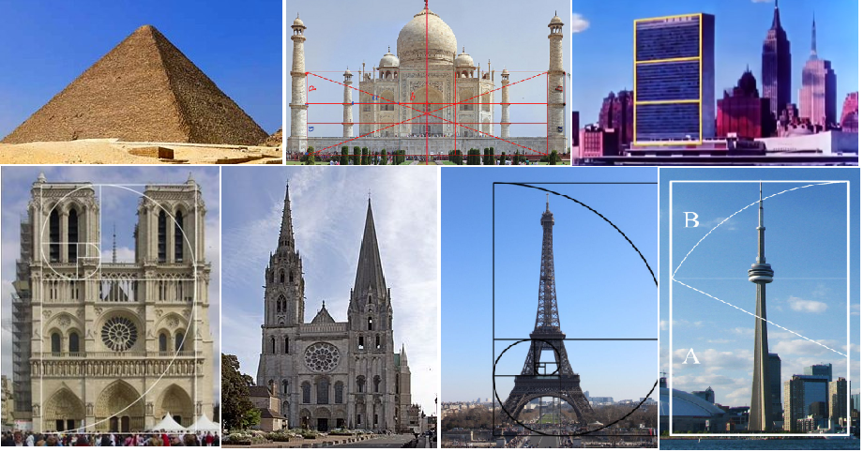

**BEHAVIOR OF NATURE**

Behavior of nature can be observed around us.

Natural regularities of nature:

Symmetry Fractals Spirals

Trees Meanders Waves

Foams Tessellations Cracks

Stripes Spots

***Golden Ratio can be found in the beauty of nature, the growth patterns of many plants, insects, and the universe.***



1. **Honeycombs of the bees show specific regular repeating hexagons. It uses the least amount of wax to store the honey giving a strong structure with no gaps.**
2. Zebra’s coat, the alternating pattern of blacks and white are due to mathematical rules that govern the pigmentation chemicals of its skin.



1. Spider webs illustrate a beautiful pattern. The spider creates a structure by performing innate steps.
2. The nautilus shell has natural pattern which contains a spiral shape called logarithmic spiral.

5. Age of the trees can be determined by applying **dendrochronology** which is a scientific method of dating based on the amount of rings found in the core of a tree.

6. Turtles have growth rings called **“scutes”** which are hexagonal.

Scutes estimates the age of the turtle.

Smallest scute is in the center and is the oldest one, while the largest ones on the outside are the newer ones.

7. Lightning during storms creates fractals. Foam bubbles formed by trapping pockets of gas in a liquid or solid.

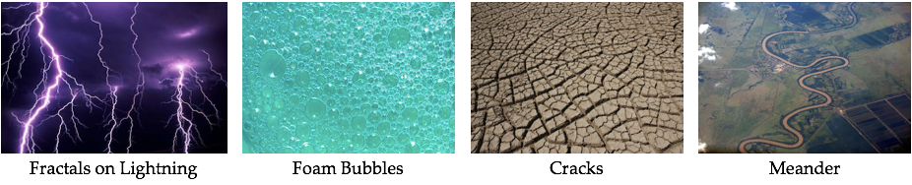

1. Cracks can also be found on the barks of trees which show some sort of weakness in the bark.

The meander is one of a series of regular sinuous curves, bends, loops, turns, or windings in the channel of the body of water.



**APPLICATIONS OF MATHEMATICS IN THE WORLD**

In our daily life, we use mathematics directly or indirectly in various fields. The application of mathematical methods in different fields such as science, engineering, business, computer science and industry is a combination of mathematical science and specialized knowledge. For example, statistics, combinatorics, and graph theory are used by investigators to solve crimes.

Other applications of mathematics are in forensic science, medicine, engineering, information technology, cryptography, archaeology, social sciences, political science and other fields.

1. ***In forensic***, mathematics is applied specifically the differential and integral calculus to clarify the blurred image to clear image. Another application of calculus is optimization (maximize or minimize) surface areas, volumes, profit and cost analysis, projectile motion, etc.
2. ***In medical field***, much of a function of a protein is determined by its shape and how the pieces move. Many drugs are designed to change the shape or motions of a protein by modeling using geometry and related areas. Mathematics is also being applied in the development of medicine to cure diseases.
3. ***In fluid dynamics***, engineers use numerical analysis in phenomena involving heat, electricity and magnetism, relativistic mechanics, quantum mechanics and other theoretical constructs.
4. ***In Information Technology***, modern computer are invented through the help of mathematics. An important area of applications of mathematics in the development of formal mathematical theories related to the development of computer science. Computer science development includes logic, relations, functions, basic set theory, counting techniques, graph theory, combinatorics, discrete probability, recursion, recurrence relations and number theory, computer-oriented numerical analysis and Operation Research techniques.
5. ***Cryptography*** is a combination of both mathematics and computer science and is affiliated closely with information theory, computer security and engineering. It is used in applications present in technologically advanced societies, examples include the security of ATM cards, computer passwords and electronic commerce.
6. ***In archaeology***, archaeologists use a variety of mathematical and statistical techniques to present the data from archaeological surveys and try to find patterns to shed on past human behavior an in carbon dating artifacts.
7. ***In Social Sciences*** such as economics, sociology, psychology and linguistics all now make extensive use of mathematical models, using the tools of calculus, probability, game theory, and network theory.
8. ***In Economics***, mathematics such as matrices, probability and statistics are used. The models may be stochastic or deterministic, linear or non-linear, static or dynamic, continuous or discrete and all types of algebraic, differential, difference and integral equations arise for the solution of these models.
9. ***In political Science***, political analysts study past election results to see changes in voting patterns and the influence of various factors on voting behavior or switching of votes among political parties and mathematical models for Conflict Resolution using Game Theory and Statistics.
10. ***In music and arts,*** the rhythm that we find in all music notes is the result of innumerable permutations and combinations. Music theorists understand musical structure and communicate new ways of hearing music by applying set theory, abstract algebra, and number theory.

Module #2

**THE NATURE OF MATHEMATICS**

**Mathematical Patterns**

1. Fibonacci Sequence
2. Arithmetic Progression
3. Geometric Progression
   * Fibonacci Sequence - is a sequence of numbers in which each successive number in the sequence is obtained by adding the two previous numbers in the sequence.

**Finding different ways to find the Fibonacci Number**:

a.) 𝒇 ≈ 𝑭 ∗ [√𝟓 +𝟏](𝒏−𝒌) **where :** 𝒇 **= nth Fibonacci number**

𝒏 𝒌 𝟐 𝒏

𝑭𝒌**= any known F. number**

**Example 1**: Find the **20th** Fibonacci number:

Fibonacci Numbers are:

0, 1, 1, 2, 3, 5, 8, 13, 21, 34, 55, 89, 144, 233, 377, …

Use 𝑭𝟏𝟐 = 144; (𝒏 − 𝒌) = 20 – 12 =8 Substituting to the above equation:

𝒇 ≈ 𝑭 ∗ [√𝟓 +𝟏](𝟖) ≈ 𝟏𝟒𝟒 ∗ (𝟏. 𝟔𝟏𝟖𝟎𝟑)𝟖

𝟐𝟎 𝟏𝟐 𝟐

≈ 6764.93 ≈ **6,765**

**b.) Finding the nth term of the Fibonacci Sequence**

(𝟏 + √𝟓) 𝒏− (𝟏− √𝟓) 𝒏

𝑭𝒏 = √𝟓∗𝟐𝒏

* + **Arithmetic Progression -** is a sequence of numbers such that the difference of any two successive members is a constant.

**Finding the nth term of the Arithmetic Series**

𝒕𝒏 = 𝒂 + (𝒏 − 𝟏)𝒅

**Finding the Sum of terms in the Arithmetic Series**

𝑺 = 𝒏 [𝟐𝒂 + (𝒏 − 𝟏)𝒅]

𝒏 𝟐

where: 𝑡𝑛 = nth term of the series n = no. of terms

𝑎 = first term

𝑑 = common difference between terms

𝑆𝑛 = sum of terms

**Exercise**: An arithmetic series contains 17 terms. If the first term is 2 and the sum is – 170. What is the common difference? **(ans. -3/2**)

* **Geometric sequence** is a sequence such that any element after the first is obtained by multiplying the preceding element by a constant called the **common ratio**.

𝑛

𝑆 = 𝑎(1−𝑟 ) **where:** 𝑆 = sum of terms

𝑛 1−𝑟

𝒓 **= the common ratio**

𝒂 **= first term**

**n = number of terms Example: 1.** Find the succeeding terms of 4, 2, 1, … ratio = 1/2

**4, 2, 1, ½, ¼ , 1/8 …**

**2. Find the sum of the first 6 terms of the above series**

1 6

𝑛 4 [1−( ) ]

Using 𝑆 = 𝑎(1−𝑟 ) = 2 = 77 = 7.875

𝑛 1−𝑟 1−(1) 8

2

**Exercise**: Find the first three terms of a geometric progression whose sum is 42 and whose product is 512. Let the first three terms of a geometric progression be a/r, a, ar

𝑎 𝑎

Given: + 𝑎 + 𝑎𝑟 = 42; ∗ 𝑎 ∗ 𝑎𝑟 = 512

𝑟 𝑟

Solution:

𝑎 ∗ 𝑎 ∗ 𝑎𝑟 = 512 ≫ 𝑎3 = 512 ≫ 𝑎 = 8

𝑟

𝑎

Substitute value of 𝑎 = 8 to + 𝑎 + 𝑎𝑟 = 42

𝑟

8 + 8 + 8𝑟 = 42; 𝒓 = 𝟏 ; 𝒓 = 𝟒

𝑟 𝟒

𝟏 𝑎

**For** 𝒓 = **, Then the three terms** , 𝑎, 𝑎𝑟

𝟒 𝑟

≫ 32, 8, 2

𝑎

**For** 𝒓 = 𝟒 **, Then the three terms** , 𝑎, 𝑎𝑟

𝑟

≫ 2, 8, 32

**Lesson Proper**

A. The characteristics of a mathematical language:

1. Precise - able to make very fine distinctions
2. Concise - able to say things briefly
3. Powerful - able to express complex thoughts with relative ease Like any language, mathematics has its own symbols, syntax and rules

* **Expression** or **mathematical expression** is a finite combination of [symbols](https://en.wikipedia.org/wiki/Symbol) that is [well-formed](https://en.wikipedia.org/wiki/Well-formed_formula) according to rules that depend on the context.

Mathematical symbols can designate numbers, operations, functions,

[brackets,](https://en.wikipedia.org/wiki/Bracket_(mathematics)) punctuation, and grouping to help determine order of [operations,](https://en.wikipedia.org/wiki/Order_of_operations) and other aspects of [logical syntax.](https://en.wikipedia.org/wiki/Syntax_(logic))

**Examples:**

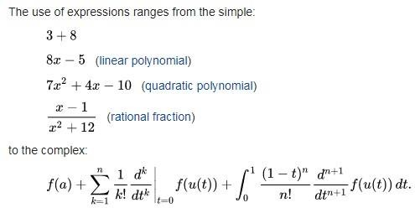

* **Sentences or Statements**

Kinds of Mathematical Sentences:

* 1. A **universal statement** – says that a certain property is true for all elements in a set. **Ex 1**. All positive numbers are greater than zero.
  2. A **conditional statement** – says that if one thing is true then some other thing also has to be true. **Ex 2**. If 378 is divisible by 18, then 378 is divisible by 6.
  3. An **existential statement** – says that there is at least one thing for which the property is true. **Ex 3**. There is a prime number that is even.

**Exercises**: Fill in the blanks to rewrite the following statements” For all real numbers x, if x is nonzero then x2 is positive.

* + 1. If a real number is nonzero, then it’s square is _.
    2. For all nonzero real numbers x, _
    3. If x then _ _
    4. The square of any nonzero real number is _.
    5. All nonzero real numbers have .
       1. Is positive
       2. $x^{2}$ is positive
 $is a nonzero real number, x^{2} is positive$

      3. Positive
       4. Positive squares (or. Squares that are positive)

**Purposive Communication**

|  |  |
| --- | --- |
| **Name: Namias, Jhon Keneth Ryan B.** | **Class: BSCS 1A** |

**Activity #2 Fibonacci/Arithmetic/Geometric Progression**

1. FIBONACCI NUMBER
2. Determine:
3. F25

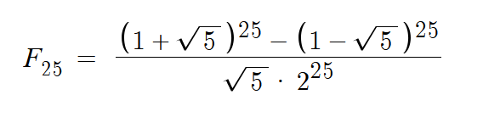

**75025**

1. 𝐹25 +𝐹36 + 𝐹10 ÷ 11

𝐹25 = 75025

𝐹36 = 14930352

𝐹10 = 55

(75025 + 14930352 + 55) / 11=

1364130.18182

1. (𝐹7 +𝐹8 +⋯+ 𝐹16) ÷ 11= 𝐹𝑛 what is n?

F7 = 13

F8 = 21

F9 = 34

F10 = 55

F11 = 89

F12 = 144

F13 = 233

F14 = 377

F15 = 610

F16 = 987

(𝐹7 +𝐹8 +⋯+ 𝐹16) = 2563

2563 / 11= 233

**F13**

1. Suppose a pair of rabbits will produce a new pair of rabbits in their second month and thereafter will produce a new pair every month. The new rabbit will do exactly the same. Start with one pair. How many pairs will there be in 10 months?
2. 2
3. 4
4. 8
5. 16
6. 32
7. 64
8. 128
9. 256
10. 512
11. 1024

**1024 rabbits**

1. Classify the given sequences as to arithmetic, geometric, Fibonacci-type, or none of the above. Find the next term for each sequence.
2. 15, 30, 60, 120…

**240**

1. 15, 30, 45, 60 …

75

1. 15, 30, 45, 75 …

**120**

1. 15, 20, 26, 33…

**41**

1. 15, 30, 90, 360 …

**1800**

1. Find the fifth and the nth term of the geometric sequence whose initial term a and common ratio r are given: a = 3; r = 2

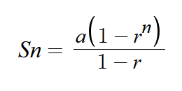

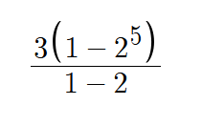

**93**

1. Find the 𝑆100 for the arithmetic sequence with the given values for a and d

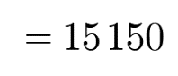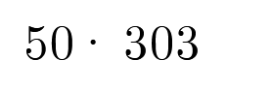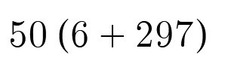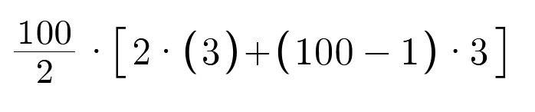𝑎1=3; 𝑑=3

**6 Operation**

* + - 1. Involution - $5^{2}$
      2. Evolution - $\sqrt{25}$
      3. M/D
      4. A/S

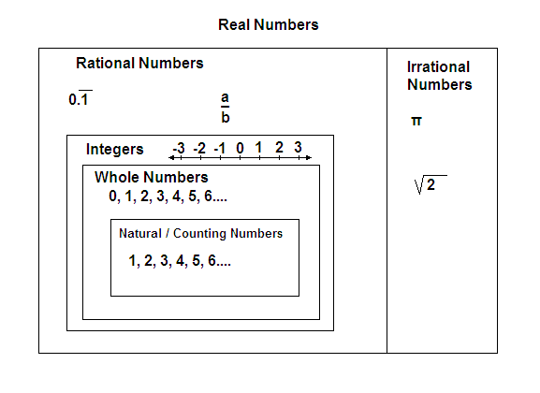

**Number Sets**

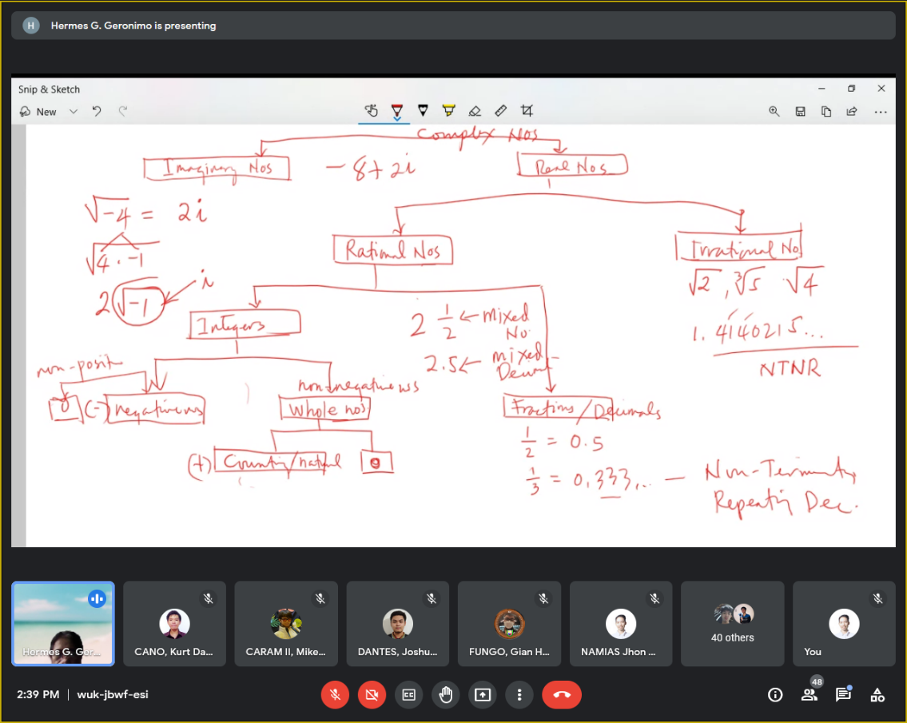

**Divisibility Rules**

**Divisibility Rule of 1**

Every number is divisible by 1. Divisibility rule for 1 doesn’t have any condition. Any number divided by 1 will give the number itself, irrespective of how large the number is. For example, 3 is divisible by 1 and 3000 is also divisible by 1 completely.

**Divisibility Rule of 2**

If a number is even or a number whose last digit is an even number i.e. 2,4,6,8 including 0, it is always completely divisible by 2.

Example: 508 is an even number and is divisible by 2 but 509 is not an even number, hence it is not divisible by 2. Procedure to check whether 508 is divisible by 2 or not is as follows:

Consider the number 508

Just take the last digit 8 and divide it by 2

If the last digit 8 is divisible by 2 then the number 508 is also divisible by 2.

**Divisibility Rules for 3**

Divisibility rule for 3 states that a number is completely divisible by 3 if the sum of its digits is divisible by 3.

Consider a number, 308. To check whether 308 is divisible by 3 or not, take sum of the digits (i.e. 3+0+8= 11). Now check whether the sum is divisible by 3 or not. If the sum is a multiple of 3, then the original number is also divisible by 3. Here, since 11 is not divisible by 3, 308 is also not divisible by 3.

Similarly, 516 is divisible by 3 completely as the sum of its digits i.e. 5+1+6=12, is a multiple of 3.

**Divisibility Rule of 4**

If the last two digits of a number are divisible by 4, then that number is a multiple of 4 and is divisible by 4 completely.

Example: Take the number 2308. Consider the last two digits i.e. 08. As 08 is divisible by 4, the original number 2308 is also divisible by 4.

**Divisibility Rule of 5**

Numbers, which last with digits, 0 or 5 are always divisible by 5.

Example: 10, 10000, 10000005, 595, 396524850, etc.

**Divisibility Rule of 6**

Numbers which are divisible by both 2 and 3 are divisible by 6. That is, if the last digit of the given number is even and the sum of its digits is a multiple of 3, then the given number is also a multiple of 6.

Example: 630, the number is divisible by 2 as the last digit is 0.

The sum of digits is 6+3+0 = 9, which is also divisible by 3.

Hence, 630 is divisible by 6.

**Divisibility Rules for 7**

The rule for divisibility by 7 is a bit complicated which can be understood by the steps given below:

Divisibility rule of 7

Example: Is 1073 divisible by 7?

From the rule stated remove 3 from the number and double it, which becomes 6.

Remaining number becomes 107, so 107-6 = 101.

Repeating the process one more time, we have 1 x 2 = 2.

Remaining number 10 – 2 = 8.

As 8 is not divisible by 7, hence the number 1073 is not divisible by 7.

**Divisibility Rule of 8**

If the last three digits of a number are divisible by 8, then the number is completely divisible by 8.

Example: Take number 24344. Consider the last two digits i.e. 344. As 344 is divisible by 8, the original number 24344 is also divisible by 8.

**Divisibility Rule of 9**

The rule for divisibility by 9 is similar to divisibility rule for 3. That is, if the sum of digits of the number is divisible by 9, then the number itself is divisible by 9.

Example: Consider 78532, as the sum of its digits (7+8+5+3+2) is 25, which is not divisible by 9, hence 78532 is not divisible by 9.

**Divisibility Rule of 10**

Divisibility rule for 10 states that any number whose last digit is 0, is divisible by 10.

Example: 10, 20, 30, 1000, 5000, 60000, etc.

**Divisibility Rules for 11**

If the difference of the sum of alternative digits of a number is divisible by 11, then that number is divisible by 11 completely.

In order to check whether a number like 2143 is divisible by 11, below is the following procedure.

Group the alternative digits i.e. digits which are in odd places together and digits in even places together. Here 24 and 13 are two groups.

Take the sum of the digits of each group i.e. 2+4=6 and 1+3= 4

Now find the difference of the sums; 6-4=2

If the difference is divisible by 11, then the original number is also divisible by 11. Here 2 is the difference which is not divisible by 11.

Therefore, 2143 is not divisible by 11.

A few more conditions are there to test the divisibility of a number by 11. They are explained here with the help of examples:

If the number of digits of a number is even, then add the first digit and subtract the last digit from the rest of the number.

Example: 3784

Number of digits = 4

Now, 78 + 3 – 4 = 77 = 7 × 11

Thus, 3784 is divisible by 11.

If the number of digits of a number is odd, then subtract the first and the last digits from the rest of the number.

Example: 82907

Number of digits = 5

Now, 290 – 8 – 7 = 275 × 11

Thus, 82907 is divisible by 11.

Form the groups of two digits from the right end digit to the left end of the number and add the resultant groups. If the sum is a multiple of 11, then the number is divisible by 11.

Example: 3774 := 37 + 74 = 111 := 1 + 11 = 12

3774 is not divisible by 11.

253 := 2 + 53 = 55 = 5 × 11

253 is divisible by 11.

Subtract the last digit of the number from the rest of the number. If the resultant value is a multiple of 11, then the original number will be divisible by 11.

Example: 9647

9647 := 964 – 7 = 957

957 := 95 – 7 = 88 = 8 × 11

Thus, 9647 is divisible by 11.

**Divisibility Rule of 12**

If the number is divisible by both 3 and 4, then the number is divisible by 12 exactly.

Example: 5864

Sum of the digits = 5 + 8 + 6 + 4 = 23 (not a multiple of 3)

Last two digits = 64 (divisible by 4)

The given number 5864 is divisible by 4 but not by 3; hence, it is not divisible by 12.

**Divisibility Rules for 13**

For any given number, to check if it is divisible by 13, we have to add four times of the last digit of the number to the remaining number and repeat the process until you get a two-digit number. Now check if that two-digit number is divisible by 13 or not. If it is divisible, then the given number is divisible by 13.

For example: 2795 → 279 + (5 x 4)

→ 279 + (20)

→ 299

→ 29 + (9 x 4)

→ 29 + 36

→65

Number 65 is divisible by 13, 13 x 5 = 65.

**Convert English sentence/expressions to Mathematical Symbols.**

A.

2x=14 1. Twice a number equals fourteen.

3(2x-1) = 4 2. Thrice the difference of twice a number and one is four.

3. The ratio of twice the sum of a number and one, and three is equal to five.

2x-5 4. Five less than twice a number.

x+y=10 5. The sum of two numbers is 10. Represent the two numbers in symbols.

X,x+1, x+2, 6. Give the representation of three consecutive integers.

X, x+2,x+4,x+6,x+8 7. Give the representation of four consecutive odd integers.

1. Jess is twice as old as Dan, and Dan is four times as old as Jun. Express each of their ages in terms of X.

Let x = Jun’s age

4x = Dan

2(4x) = Jess

1. The perimeter and area of a rectangle if one side is 8 feet longer than twice the other side. Express their area and perimeter in terms of X.
2. Jun had 5 centavo and 10 centavo coins with a total of 100 coins. How many pieces of 5 and 10 centavo coins are there. Express answers in terms of X.

**EXERCISE #1**

**A. Convert English sentence/expressions to Mathematical Symbols.**

1. Twice a number equals fourteen.

2x = 14

2. Thrice the difference of twice a number and one is four.

3(2x+1) = 4

3. The ratio of twice the sum of a number and one, and three is equal to five.

(2x+1)/3=5

4. Five less than twice a number.

2x-5

5. The sum of two numbers is 10. Represent the two numbers in symbols.

X+y = 10

6. Give the representation of three consecutive integers.

X, x+1, x+2

7. Give the representation of four consecutive odd integers.

X, x+2, x+4, x+6

**B. Represent the problems:**

8. Jess is twice as old as Dan, and Dan is four times as old as Jun. Express each of their ages

in terms of X .

jun = x

dan = 4x

jexx = 2(4x)

9. The perimeter and area of a rectangle if one side is 8 feet longer than twice the other side.

Express their area and perimeter in terms of X.

Let legth = x

8+2x

10. Jun had 5centavo and 10 centavo coins with a total of 100 coins. How many pieces of 5 and

10 centavo coins are there. Express answers in terms of X.

**MATHEMATICS IN THE MODERN WORLD**

**ACTIVITY#3-PROBLEM SOLVING**

A. Convert the following English statements to numerical statements and symbols. Express as

Write your answer on the space provided:

1. The quotient of “fifteen and five” and “twelve and four” is one. (15

2. The difference between the squares of two consecutive odd integers_________________

_______________________________

3. Toni is thrice as old as Raul, and Raul is half as older as Rene. Express each of their ages in

Terms of a single unknown. __________________________________________________

4. The three angles A, B and C of triangle ABC if A exceeds twice angle B by 20°.Express all the

angles _________________________________________________

5. The time it takes a boat traveling at a speed of 1 mi/her to cover a distance of x miles.

______________________________

B. Solve the following problems:

1. If 2 persons’ handshake only once with everyone else, how many handshakes occur in

6 people. Use letters A, B, C, D, E and F to name and count the handshakes.

2. There are four volumes of Shakespeare’s collected works on a shelf. The volumes are in

order from left to right. The pages of each volume are exactly two inches thick. The covers

are each 1/6 inch thick. A bookworm started eating at page one of Volume I and ate through

to the last page of Volume IV. What is the distance the bookworm travelled?

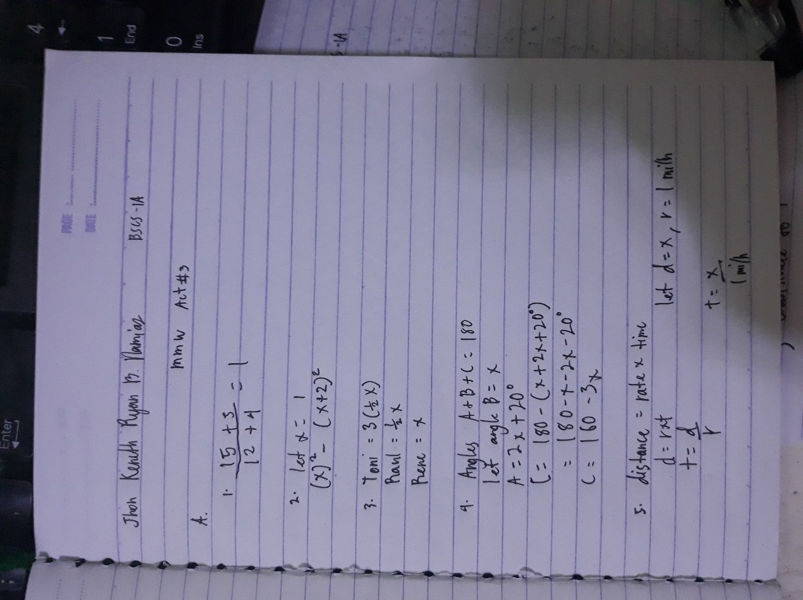

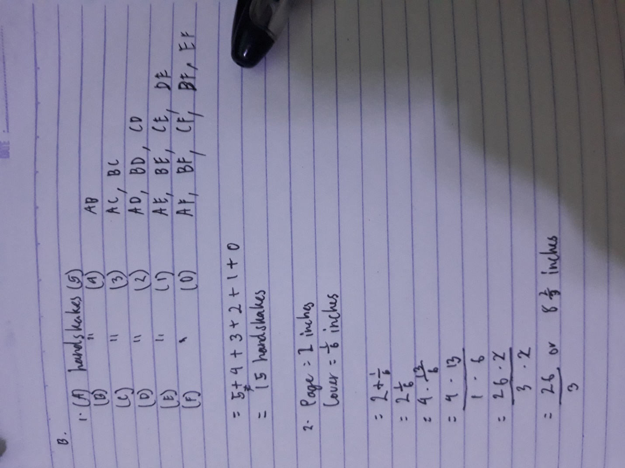

**Definition of Terms**

A **population -** any specific collection of objects of interest.

A **sample** - any subset of a larger set of data – to draw inferences about the larger set called the population

**Statistics** - is a collection of methods for collecting, displaying, analyzing, and drawing conclusions from data.

**Division/Branches of Statistics**

* **Descriptive statistics** - is the branch of statistics that involves organizing, displaying, and describing data.
* **Inferential statistics** - is the branch of statistics that involves drawing conclusions about a population based on information contained in a sample taken from that population.

**Types of Data/ Qualitative and Quantitative Variables**

* **Qualitative data** - are measurements for which there is no natural numerical scale, but which consist of attributes, labels, or other non- numerical characteristics.
* **Quantitative data** - are numerical measurements that arise from a natural numerical scale.

**Types of Quantitative Data**:

**Continuous data** - data that can take any value. Height,

weight, temperature and length are all examples of data that will change over time;

**Discrete data -** data that can only take certain or fixed values**.**

**Types of Sampling:**

* **PROBABILITY SAMPLING**: Simple Random Sampling. Stratified Random

Sampling. Systematic Sampling. ...

* **NON-PROBABILITY SAMPLING**: Purposive Sampling. Convenience Sampling. Snow-ball Sampling.

**Sampling Techniques**

* **Simple Random Sampling** - such sampling requires every member of the population to have an equal chance of being selected into the samples. Chooses a sample by pure chance
* **Random assignment** – random division of samples into two groups. One group is assigned to the treatment condition and the other group is assigned to the control condition. This random division of the sample is critical for the validity of an experiment.
* **Stratified Sampling -** used to make the sample more representative of the population. This method can be used if the population has a number of distinct “strata” or groups.
* **Cluster sampling** – the researcher divides the population into separate groups, called clusters or this is also known as area sampling.
* **Systematic Random Sampling** - probability sampling method in which sample members from a larger population are selected according to a random starting point but with a fixed, periodic interval.

**Variables -** are properties or characteristics of some event, object, or person that can take on different values or amounts.

When conducting research, experimenters often manipulate variables. For example, an experimenter might compare the effectiveness of four types of antidepressants. In this case, the variable is “type of antidepressant.” When a variable is manipulated by an experimenter, it is called an independent variable. The experiment seeks to determine the effect of the **independent variable** on relief from depression. In this example, relief from depression is called a dependent variable. In general, the independent variable is manipulated by the experimenter and its effects on the **dependent variable** are measured.

**Types of Variables**

* **Independent variable** - the variable the experimenter changes or controls and is assumed to have a direct effect on the dependent variable or the “predictor”
* **Dependent variable** – predicted variable or measured variable

**Levels of an Independent Variable -** is the number of experimental conditions.

If an experiment compares an experimental treatment with a control treatment, then the independent variable (type of treatment) has two levels: **experimental and control.** If an experiment were comparing five types of diets, then the independent variable (type of diet) would have 5 levels.

**Scales or Level of Measurement of Data**

* **Nominal Scale** - Nominal or categorical variables that can be placed into categories. They don’t have a numeric value and so cannot be added, subtracted, divided or multiplied.

**Ordinal Scale** - contains things that you can place in order. For example, hottest to coldest, lightest to heaviest, richest to poorest. Tells something about ranking of data say 1st, 2nd, 3rd place (and so on),

**Interval Scale** - ordered numbers with meaningful divisions. Temperature is on the interval scale: a difference of 10 degrees between 90 and 100 means the same as 10 degrees between 150 and 160. Zero is not considered a data

**Ratio Scale -** exactly the same as the interval scale with one major difference: zero is meaningful. For example, a temperature of zero degree Celsius , which exists as the freezing point for water.

### **Presentation of Data**

**Data list** - is an explicit listing of all the individual measurements, either as display with space between the individual measurements, or in set notation with individual measurements separated by commas.

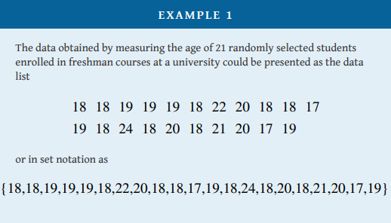

**Data frequency table** - a table in which each distinct value x is listed in the first row and its frequency (f), which is the number of times the value x appears in the data set, is listed below it in the second row

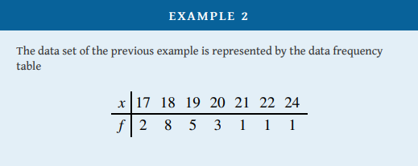

### **Three Popular Data Displays or Graphical Representation of Data**

* **Stem and Leaf Diagrams**

### **Frequency Histograms**

* **Relative Frequency Histograms**

### **Use the different ways to present the data graphically:**

Suppose 30 students in a statistics class took a test and made the following scores**:**

**Graphical Representation of Data:**

* 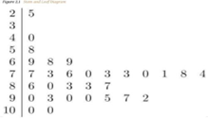**Stem and Leaf Diagram**

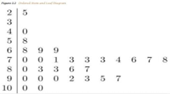

## Frequency Histograms

## 

* **Relative Frequency Histograms**

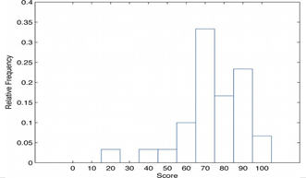

It is exactly the same as the frequency histogram except that the vertical axis in the relative frequency histogram is not frequency but relative frequency.

The same procedure can be applied to any collection of numerical data. Classes are selected, the relative frequency of each class is noted, the classes are arranged and indicated in order on the horizontal axis, and for each class a vertical bar, whose length is the relative frequency of the class, is drawn. The resulting display is a relative frequency histogram for the data.

### **A. Frequency Distribution Table**

-is a method of organizing raw data in a compact form by displaying a series of scores in ascending or descending order, together with the number of times each score or data that occurs in the respective data set.

**How to set up a Frequency Distribution Table**

1. 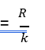Compute the range: R = highest – lowest data
2. Compute the class width or class size (𝑐) by: (𝑐) =

where the desired number of class intervals (𝑘) is given or can be determined using the formula: 𝑘 = 1 + 3.3 log 𝑁

1. Using the class size set up the lower and upper class limits.
2. Tally the scores or data.
3. Add all the tallied scores in each class interval to be the frequency interval 𝑓𝑖.
4. Set up the less than and greater than Cumulative frequency

𝐶𝑓> 𝑜𝑟 𝐶𝑓<

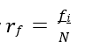

1. Compute the relative frequency

### **Given the following data, set up a frequency distribution table USING**

### **Eight class intervals:**

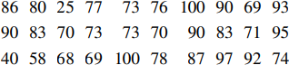

|  |  |  |  |  |
| --- | --- | --- | --- | --- |
| CLASS LIMITS | TALLY | INTERVAL FREQUENCY | CUMULATIVE FREQUENCY | RELATIVE FREQUENCY |
|  |  |  |  |  |
|  |  |  |  |  |
|  |  |  |  |  |

**The Frequency Distribution Table:**

|  |  |  |  |  |
| --- | --- | --- | --- | --- |
| **CLASS LIMITS**  **Scores** | **FREQUENCY INTERVAL** | **CUMULATIVE FREQUENCY**  **< >** | | **RELATIVE FREQUENCY** |
| 91-100 | 6 | 30 | 6 | 0.200 |
| 81-90 | 7 | 24 | 13 | 0.233 |
| 71-80 | 9 | 17 | 22 | 0.300 |
| 61-70 | 5 | 8 | 27 | 0.167 |
| 51-60 | 1 | 3 | 28 | 0.033 |
| 41-50 | 0 | 3 | 28 | 0.000 |
| 31-40 | 1 | 2 | 29 | 0.033 |
| 21-30 | 1 | 1 | 30 | 0.033 |
| TOTAL | 30 |  | | 0.999 |

Continuation on the Steps of Setting up a Distribution Table :

1. Set your lower and upper class boundaries.
2. Compute the Class Mark or the Midpoint.

**The following table is a sample of a frequency distribution table in a Descriptive Measured:**

|  |  |  |  |
| --- | --- | --- | --- |
| **CLASS LIMITS**  **Scores** | **FREQUENCY INTERVAL** | **CLASS BOUNDARIES** | **CLASS MARK**  **/MIDPOINT** |
| 91-100 | 6 | 90.5 – 100.5 | 95,5 |
| 81-90 | 7 | 80.5 – 90.5 | 85.5 |
| 71-80 | 9 | 70.5 – 80.5 | 75.5 |
| 61-70 | 5 | 60.5 – 70.5 | 65.5 |
| 51-60 | 1 | 50.5 – 60.5 | 55.5 |
| 41-50 | 0 | 40.5 – 50.5 | 45.5 |
| 31-40 | 1 | 30.5 – 40.5 | 35.5 |
| 21-30 | 1 | 20.5 – 30.5 | 25.5 |
| TOTAL | 30 |  |  |

**Summation Notation (** ∑ **) - Greek letter sigma**

expressing the sums of data in notation form from any point of the data to the nth number of your data as in:

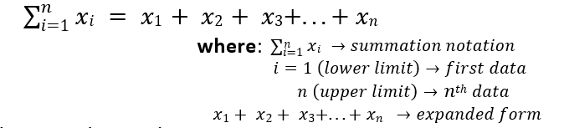

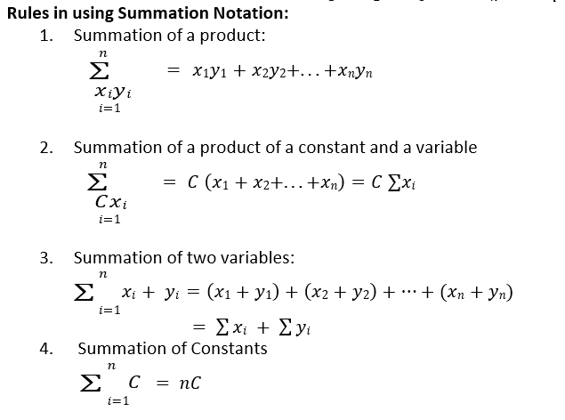

**DESCRIPTIVE MEASURES**

**MEASURES OF CENTRAL TENDENCY -**

a central tendency or typical value for a probability distribution. It may also be called a center or location of the distribution. (You can think of it as the tendency of data to cluster around a middle value.)

The three measures of central tendency are **mean, median and mode**.

**l. Ungrouped Data Computations**

**a. The Mean (Y) - arithmetic average**

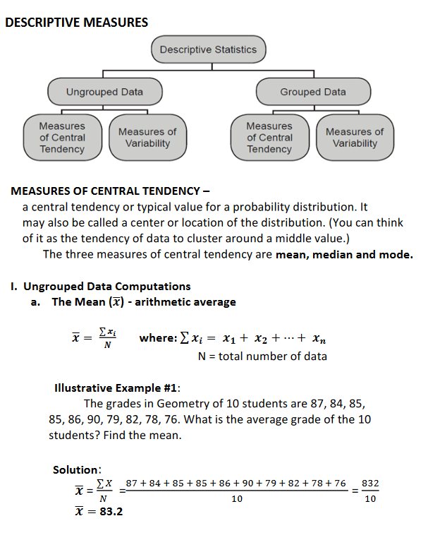

**Illustrative Example #1:**

The grades in Geometry Of 10 students are 87, 84, 85,

85, 86, 90, 79, 82, 78, 76. What is the average grade of the 10

students? Find the mean.

Solution: 

**b. The Median 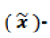 positional average**

the middlemost value in the data set. It is found midway between the highest and the lowest value in a rank order distribution and divides the distribution into two equal parts.

**If N is an odd number**, the position of the median

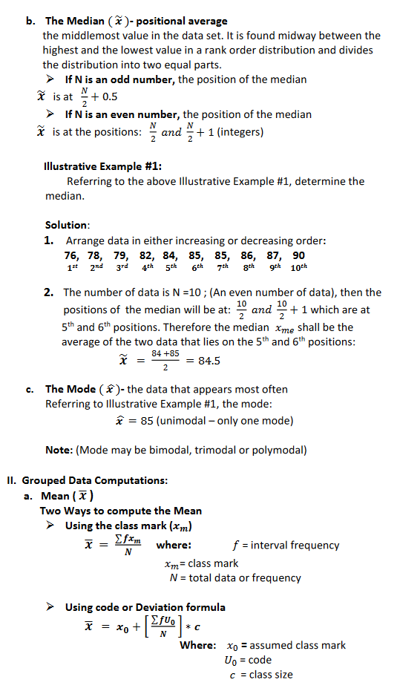

**If N is an even number**, the position of the median



**Illustrative Example #1:**

Referring to the above Illustrative Example #1, determine the median.

**Solution:**

* + - 1. Arrange data in either increasing or decreasing order:

**76, 78, 79, 82, 84, 85, 85, 86, 87, 90**

**1st 2nd 3rd 4th 5 th 6 th 7 th 8 th 9 th 10 th**

2. The number of data is N -10; (An even number of data), then the positions of the median will be at: which are at 5th and 6th positions. Therefore the median xme shall be the average of the two data that lies on the 5th and 6th positions:



**c. The Mode**  the data that appears most often

Referring to Illustrative Example #1, the mode:

= 85 (unimodal —only one mode)

Note: (Mode may be bimodal, trimodal or polymodal)

ll. Grouped Data Computations:

contradictiona. Mean ( * )

Two Ways to compute the Mean

Llo = code

Using the class mark (xm)

EfXm

where:

f = interval frequency

class mark

N = total data or frequency

Using code or Deviation formula

EfU0

xo +

Where:

xo = assumed class mark

= class size

c

tautology = if all true

contradiction = if all false

contingent = if uncertain

MATH IN THE MODERN WORLD EXAM FINALS REVIEWER

1. It is an amount where the borrower is obliged to pay before the bond is surrendered to the borrower.
   1. **ANSWER: Final redemption value**
2. The process of determining the current value of a bond
   1. **ANSWER: Bond validation**
3. In how many years will $ 21,136.18 amount to $ 75,514.55 at 27.54 % per annum when compounded quarterly?
   1. **ANSWER: 4.781**
4. The actual time in days from May 1 to Dec 15 of the same year is
   1. **ANSWER: 228**
5. It is a sequence of equal payments made at equal periods
   1. **ANSWER: Annuity**
6. It is also referred to as the principal
   1. **ANSWER: Present value**
7. The interest computed on the basis of a 360-day year
   1. **ANSWER: Ordinary interest**
8. It is one which payment begin and end at fixed times.
   1. **ANSWER: Annuity certain**
9. What rate compounded annually will double any sum in 6 years?
   1. **ANSWER: 12.25%**
10. The present worth of 20,000 with simple interest of 12% due in 9 months is
    1. **ANSWER: 18,348.62**
11. The actual number of days between May 4 and Sept 6 of the same year is
    1. **ANSWER: 125**
12. If 16,000 earns 480 in 9 months ,what is the annual rate of interest?
    1. **ANSWER: 4%**
13. How many conversion periods are there for an amount of 1000 compounded quarterly for 5 years
    1. **ANSWER: 10**
14. What kind of annuity whose payment depend on an event that cannot be foretold accurately.
    1. **ANSWER: Contingent Annuity**
15. Which is regarded as an annuity?
    1. **ANSWER: Monthly rental**
16. Accumulate 5,000 for 10 years at 8% compounded quarterly.
    1. **ANSWER: 11,040.20**
17. It is an interest computed based on the original principal and the accumulated past interest.
    1. **ANSWER: Compound Interest**
18. It is an interest bearing contract which obligates the borrower to make payments of interest and principal on specific dates to the holder of the bond
    1. **ANSWER: Bond**
19. It is an interest computed based on the original principal during the whole life of investment
    1. **ANSWER: simple**
20. It refers to a system of arithmetic for integers, which considers the remainder.
    1. **ANSWER: Modular Arithmetic**
21. It is found by assuming each month to be 30 days
    1. **ANSWER: Approximate time**
22. The exact simple interest on 5,000 for the period of January 15 to November 28,1992 if the interest rate is 22%
    1. **ANSWER: 955.74**
23. At a certain interest compounded semiannually, 5,000 will amount 20,000 in 10 years. What is the amount at the end of 15 years?
    1. **ANSWER: 40,029.72**
24. It refers to the bond rate or coupon rate
    1. **ANSWER: Nominal rate**
25. How long will 1,000 amount to 1,346 if invested at 6% compounded quarterly?
    1. **ANSWER: 5 years**
26. The maturity value of a loan of Php 10,000 and interest half of the principal
    1. **ANSWER: 15,000**
27. If money is worth 4% compounded monthly ,what payment at the end of each quarter will replace payments of Php 500.00 monthly
    1. **ANSWER: 1,505.00**
28. Find the final output of this proposition (((P ∨ Q) → (R ∧ S)) ↔ ¬(¬T ↔ Q)).
    1. **ANSWER: TFFTFTFTFTTFTFTFTFFTFTFTFTFTFTFT**
29. What rate compounded quarterly is equivalent to 14% compounded semiannually?
    1. **ANSWER: 13.76%**
30. How long will 4,000 to 14,000 at a simple interest rate of 12.5% ?
    1. **ANSWER: 20 years**
31. Which covers the longest time?
    1. **ANSWER: 800 days**
32. Given this UPC number 61414x000036, find the 6th digit x.
    1. **ANSWER: 1**
33. Find the present value of an ordinary annuity which has payments of $19157.64 per year for 24 years at 12.34 % compounded quarterly.
    1. **ANSWER: $ 532159.76**
34. The largest interest can be obtained when compounded.
    1. **ANSWER: monthly**
35. It is a connective that results to FALSE only when the antecedent is true and the component is false.
    1. **ANSWER: Conditional**
36. A loan of Php 2000 is made for a period of 13 months at a simple interest rate of 20%. What is the maturity value?
    1. **ANSWER: 2,433.33**
37. How long will it take for 500 to accumulate to 2,000 at 12% compounded semi-annually?
    1. **ANSWER: 12.9 years**
38. A man borrowed 10,000 and agrees to pay at the end of 90 days under 8% simple interest rate. What is the required amount?
    1. **ANSWER: 10,200**
39. What is the present worth of a Php 1000 annuity over a 10-year period if interest rate is 8%?
    1. **ANSWER: 6710.00**
40. It represents the interest earned date or coupon date also referred to as coupon annuity payments
    1. **ANSWER: Periodic payment**
41. The total amount the borrower would need to repay a loan
    1. **ANSWER: Maturity value**
42. It is one whose payment depend on an event that cannot be foretold accurately.
    1. **ANSWER: contingent annuity**
43. The time between successive interest computation
    1. **ANSWER: Compounding period**
44. The compound amount when 2,000 is invested at 10% compounded every 6
45. months for 2 years.
    1. **ANSWER: 2,431.01**
46. Given this ISBN, 978073342609x. Find the check digit x?
    1. **ANSWER: 4**
47. John wants to apply for a loan, with a Present Annuity due value of $3,500,568.78 from a bank that charges 14.28 % interest per annum, compounded monthly. If he can only be able to pay back $43,367.21 per annum at the beginning of each year, When will John fully pay all of his debt to the bank?
    1. **ANSWER: 21 years**
48. Annuity where payment is done at the end of the term
    1. **ANSWER: Ordinary annuity**
49. How much must be invested today in order to have 15,500 in 2 years if money is worth 12% simple interest?
    1. **ANSWER: 12,500.00**
50. Find the interest rate on 6800 for 3 years at 11% simple interest.
    1. **ANSWER: 2,244.00**
51. What is the annual rate of interest if 265 is earned in four months on an investment of 15,000.00?
    1. **ANSWER: 5.3%**